Preparation of Papers for CIEIT 2023 (中英文投稿皆可)

First A. Author1,2, Second B. Author Jr.2, *Senior Member, IEEE,* and Third Author (第三著者)3,4, *Fellow, IEEE*

1National Institute of Standards and Technology, Boulder, CO 80305, USA

2Department of Electrical, Computer, and Energy Engineering, University of Colorado, Boulder, CO 80309, USA

3Department of Metallurgical and Materials Engineering, Colorado School of Mines, Golden, CO 80401, USA

4National Institute for Materials Science, Tsukuba, Ibaraki 305, Japan

These instructions give you guidelines for preparing papers for IEEE Transactions on Magnetics. Use this document as a template if you are using Microsoft *Word*. Otherwise, use this document just for helpful information, and prepare your paper using any word processor or LaTeX

*Index Terms*—About four key words or phrases in alphabetical order, separated by commas.

# Introduction

T

his document is a Microsoft *Word* template for IEEE Transactions on Magnetics. Use of this document as a template is optional. If you are reading a paper version of this document, please download the electronic file, transmag2015.doc, from [www.ieee.org/publications_ standards/publications/authors/author_templates.html](http://www.ieee.org/publications_standards/publications/authors/author_templates.html) so you can use it to prepare your manuscript. If you would prefer to use LaTeX, download IEEE’s LaTeX style and sample files from the same Web page. Use those LaTeX files for formatting, but please follow the instructions in transmag2015.doc (or transmag2015.pdf).

# Procedure for Paper Submission

## ScholarOne® Manuscripts

Authors of regular and conference-related papers should prepare their papers for review using Microsoft *Word* and this template or LaTeX and the files contained in IEEEtran.zip. If your paper is submitted in conjunction with a conference, please observe any page limits specified by the conference. **Do not change the font sizes or line spacing to squeeze more text into a limited number of pages. Leave some white space around your figures.** Conference-related papers follow the same review procedures as regular papers.

Regular and conference-related papers must be submitted electronically to IEEE’s on-line manuscript submission and peer-review system, *ScholarOne® Manuscripts.* Regular papers should be submitted at [mc.manuscriptcentral.com/ transmag-ieee](http://mc.manuscriptcentral.com/transmag-ieee); for conference-related papers, go to [mc.manuscriptcentral.com/magconf-ieee](http://mc.manuscriptcentral.com/magconf-ieee). You should first check if you have an existing account. If there is none, please create a new account. (Your log-in information is the same on both sites.) After logging in, go to your Author Center and click on the link, “Click here to submit a new manuscript.”

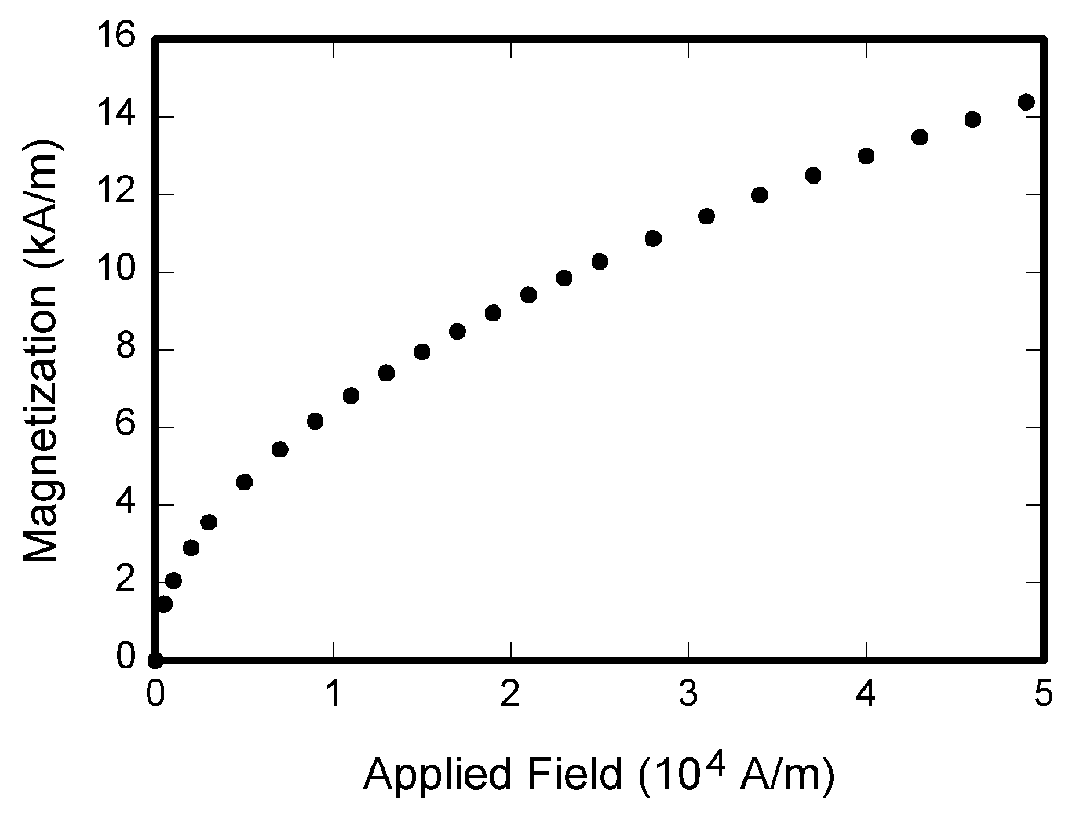

Fig. 1. Magnetization as a function of applied field. Note that “Fig.” is abbreviated. There is a period after the figure number, followed by two spaces. It is good practice to explain the significance of the figure in the caption.

# Conclusion

A conclusion section is not required. Although a conclusion may review the main points of the paper, do not replicate the abstract in the conclusion. A conclusion might elaborate on the importance of the work or suggest applications and extensions.

References

1. G. Eason, B. Noble, and I. N. Sneddon, “On certain integrals of Lipschitz-Hankel type involving products of Bessel functions*,” Phil. Trans. Roy. Soc.* London, vol. A247, pp. 529-551, Apr. 1955.
2. J. Clerk Maxwell, *A Treatise on Electricity and Magnetism,* 3rd ed., vol. 2. Oxford: Clarendon, 1892, pp. 68-73.
3. I. S. Jacobs and C. P. Bean, “Fine particles, thin films and exchange anisotropy,” in *Magnetism,* vol. III, G. T. Rado and H. Suhl, Eds. New York: Academic, 1963, pp. 271-350.